Most elegant wedding ideas
A couples wedding day is the most important day of one’s life and when it comes to planning a wedding, choosing a wedding theme becomes very important. We often see the same wedding ideas and repeatedly see the same themes, styles and arrangements over and over again. Everyone wants their wedding reception to look different and unique so we are here to help by giving ideas about some very solitary and exceptional wedding days. Let’s check out those ideas.
- Antler wedding theme
Antlers are both very unique and very aesthetic. They can be used very wisely to give a winsome touch to the wedding ceremony. Almost everything that you need for a wedding day is available and designed keeping this theme in mind. Invitation cards, show-pieces, glassware, plates, guest books, cake-topper and almost everything can be found based on this theme. This idea promises to make your wedding unique. 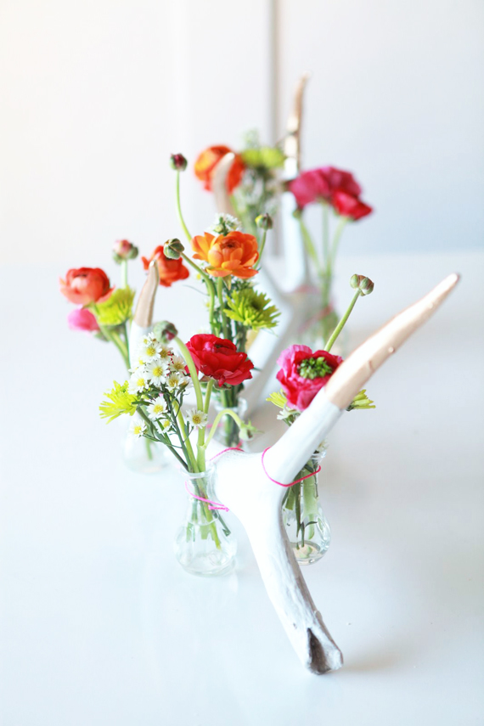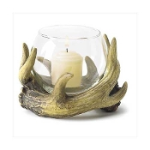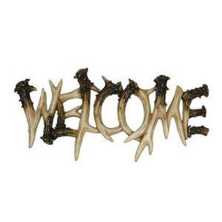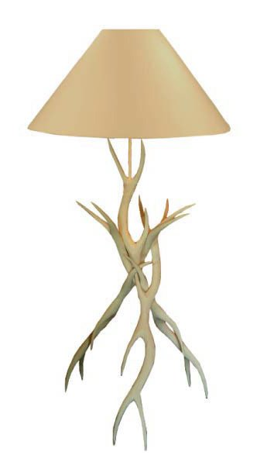
- Wedding ideas based on Birds
For a spring wedding this is a very well suited theme. It has everything. The beauty, touch of nature and simplicity are the keys of this theme. Pictures, showpieces, cards, guestbooks and also the caketoppers make this theme complete and one of a kind.
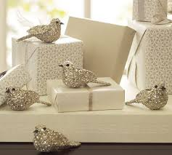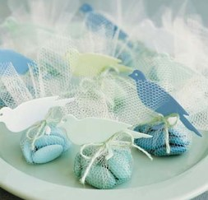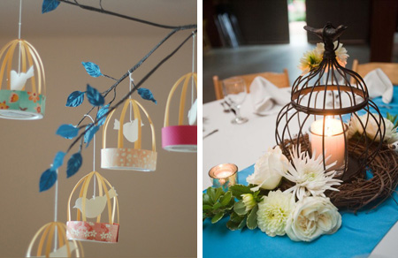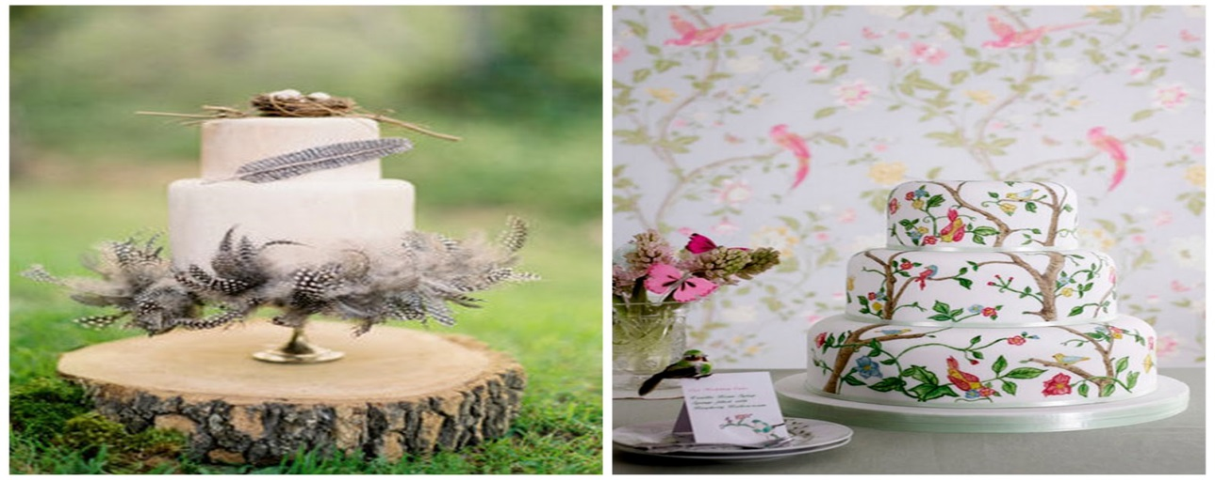
- Feather based theme
This one is a very interesting idea. Make every little thing pop up based on this theme. It is surely very appealing and eye catching. Things often look more beautiful when their design is inspired by nature. Cake toppers, cards, show-pieces, attire can be used to make this theme come out beautifully.
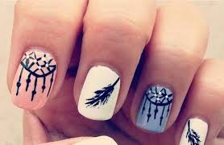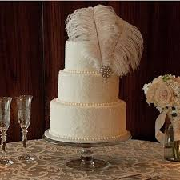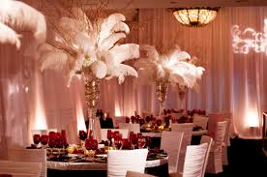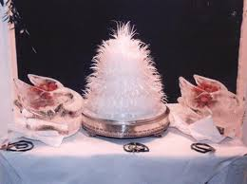

- School themed wedding
School has definitely played a crucial role in creating our individual characters. It can also have major role to play on your wedding in the form your theme. Sitting arrangements, boards, messages, pens, decorative items and geeky attire can be used to follow this theme. Check out the photos to get more idea.
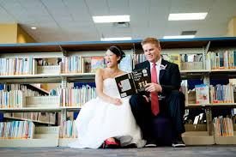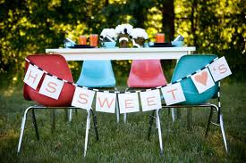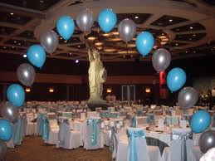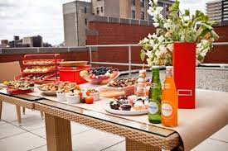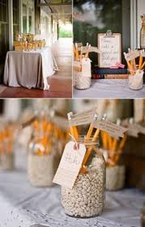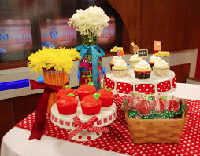

- Nature inspired woodland theme
Woodland inspired wedding themes can make your wedding day celebration very unique by incorporating nature. It gives a very stylish and elegant look to your wedding ceremony. This is preferred for outdoor or open sky locations. Check out the pictures below to get some great ideas.

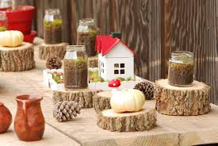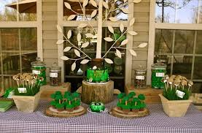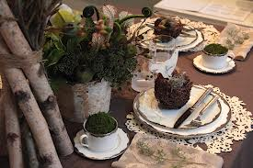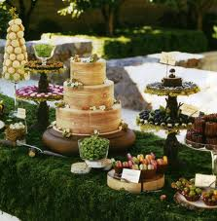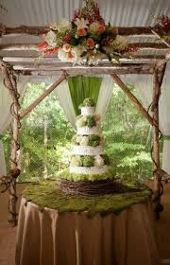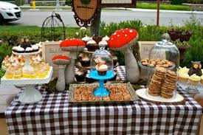

These are some of the most pretty, captivating and latest wedding ideas. You can surely make your wedding day look unique and memorable with following one of this. Thank you.

